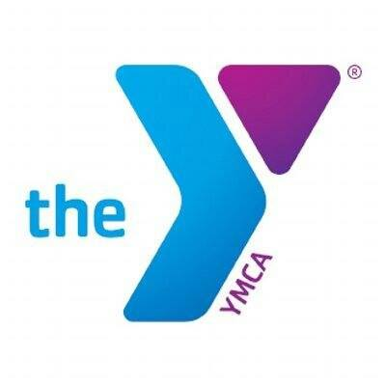
Focus of Program: The Summer Skill development clinics will help develop and finetune participants skill level. The programs are divided by age groups. YMCA staff and volunteer coaches will introduce participants to age appropriate, challenging drills and concepts that will help to further their abilities and help prepare them for their next step in their sport.

Ages | Divisions are made up of age 7-15-year-old girls.
Program Dates | Open registration: May 1 – 30. Registrations received after May 30 will be charged a $15 late fee.  Weekday Skill Development Clinics begin June 6-10 (lasting one hour each day).  1 Day Clinic/Play Day Program (lasts 2 hours) will be held June 19 and June 24.
Times | Weekday programs last 1 hour & 1- Day Clinic/Play Day will last 2 hours.  Weekday Program anticipated divisions and times:  11Under - 5:30pm  15Under- 6:45pm  1 Day Clinic/Play Day Program anticipated divisions and times:  11Under - 1pm-3pm  15Under - 3pm-5pm  Divisions subject to change based on the number of players registered.
Cost | All Weekday Skill Development Clinics: $55 members; $85 non-members  1-Day Clinic/Play Days: $25 members; $40 non-members (per day)
Skill Level | Groups are made up of recreational players of all skill levels and backgrounds. Beginners are welcome and encouraged to participate in the YMCA program. Coaches will work with each player based on their needs for growth in each skill area of the game. This is an instructional league that focuses on teaching fundamentals and skill development.
Teams | Groups/age groups are made up of 10-20 players each depending on the age division of the group. YMCA staff will divide the teams according to skill level and number of players registered for the program in each age range. Special requests are not guaranteed.
Coaches | All coaches are volunteers and have passed a criminal background check. If you are interested in coaching, please be sure to indicate that on your player’s registration form. Coaches will be trained by the YMCA Sports Staff on rules, procedures and general knowledge as needed.
Practices/Scrimmages | Each group will be scheduled a 1-hour practice with scrimmage at the North River YMCA.  Weekday Program: Practices/scrimmages will be held NO EARLIER than 5 p.m., and last until each group has time to play.  1 Day Clinic/Play Day Program: (2 hours) will start as early as1 pm and last until each group has time to play. Any necessary make-up events will be scheduled by coaches and YMCA sports staff.
Uniforms | There is no required uniform for Summer Skills Development Clinics. The YMCA will provide scrimmage jerseys, when necessary, on program days. Parents are responsible for knee sliders, shorts, and tennis shoes.
Pictures | Summer Season Volleyball pictures will not be taken. Team coaches can arrange a time during the season where team families are assembled, and parents can take group pictures.
What’s Next? | Once you have registered, you’re simply waiting on an email. All players will receive an email from their coach or the YMCA (by 6/1 Week 1 clinic) (by 7/5 Week 2 clinic) (by 6/14 Day 1 clinic by 6/14) (by 7/19 Day 2 Clinic). If you do not receive communication from the coach or YMCA by the above dates, email tcorder@ymcachattanooga.org

