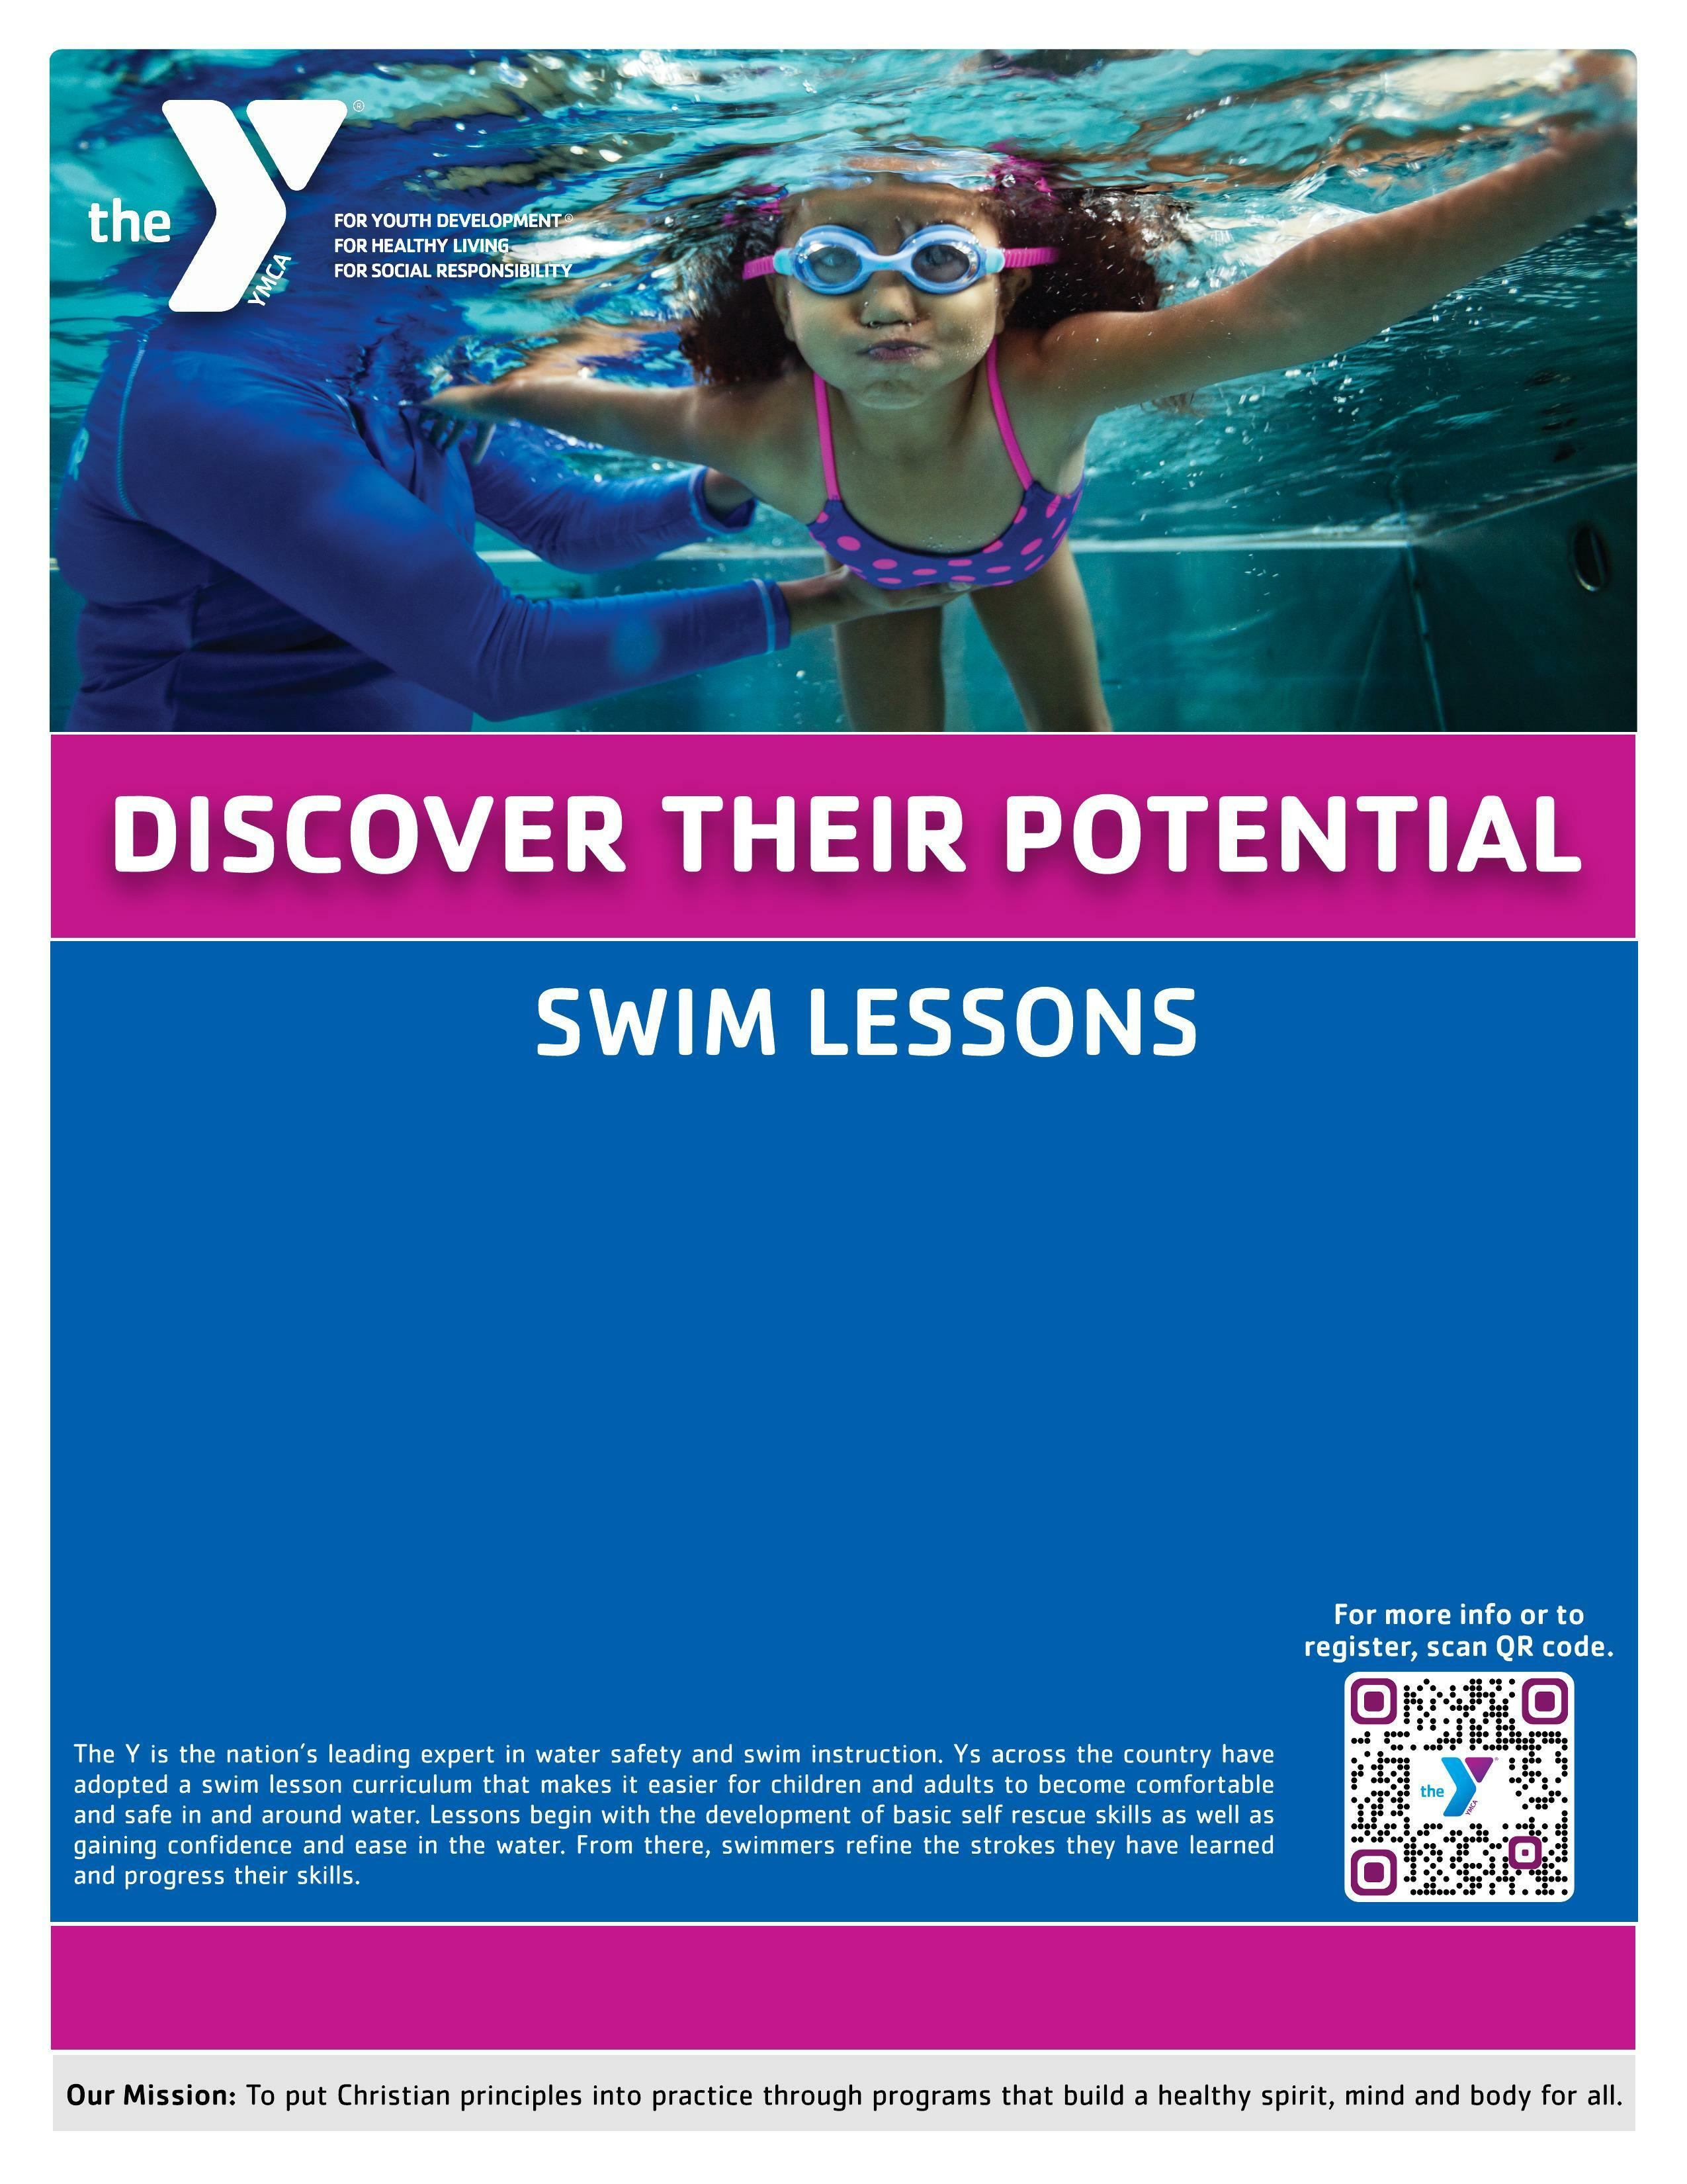

DOWNTOWN FAMILY YMCA

AUGUST & SEPTEMBER 2022
Group Lessons Semi-Private Lessons (groups of 2-3)
4 Lessons: $40 member / $65 non-member 4 Lessons: $145 member / $270 non-member
8 Lessons: $80 member / $130 non-member 10 Lessons: $345 member / $625 non-member
Private Lessons
4 Lessons: $95 member / $165 non-member
10 Lesson : $220 member / $345 non-member

Aquatics Director, Cassie Singleton csingleton@ymcachattanooga.org 423.266.3766
Class  August: September:  Mon/Wed: Aug. 1-24 Mon/Wed: Aug. 29 – Sept. 26  Tues/Thurs: Aug. 2-25 Tues/Thurs: Aug. 30 – Sept. 22  Sat: Aug. 6-27 Sat: Sept. 3-24 | Day/Time
Swim Starters (parent participation required)- Ages 6 mo-3 years
Water Discovery/Water Exploration | Thursdays 4:45 p.m.  Saturdays 10:30 a.m.
Swim Basics: Preschool- Ages 3 -5 years
Levels 1, 2, & 3- Acclimation/Movement/Stamina | Mondays/Wednesdays  11 a.m., 5:30 p.m. or 6:15 p.m.  Tuesdays/Thursdays 5:30 p.m.  Saturdays 11:15 a.m. or 12 p.m.
Swim Basics: Youth- Ages 6-12 years
Levels 1, 2, & 3- Acclimation/Movement/Stamina | Tuesdays/Thursdays 6:15 p.m.
Swim Strokes (advanced youth)- Ages 6 -12 years
Levels 4, 5, & 6- Stroke Introduction/Stroke Development/Stroke Mechanics | Mondays/Wednesdays
Adult: Ages 13+
Various skill levels | Thursdays 7 p.m.
Make up lessons are not conducted for personal absences and are only conducted if the cancels class for any reason. Make up lessons for classes extend the session one more Saturday or by adding additional minutes to remaining classes.
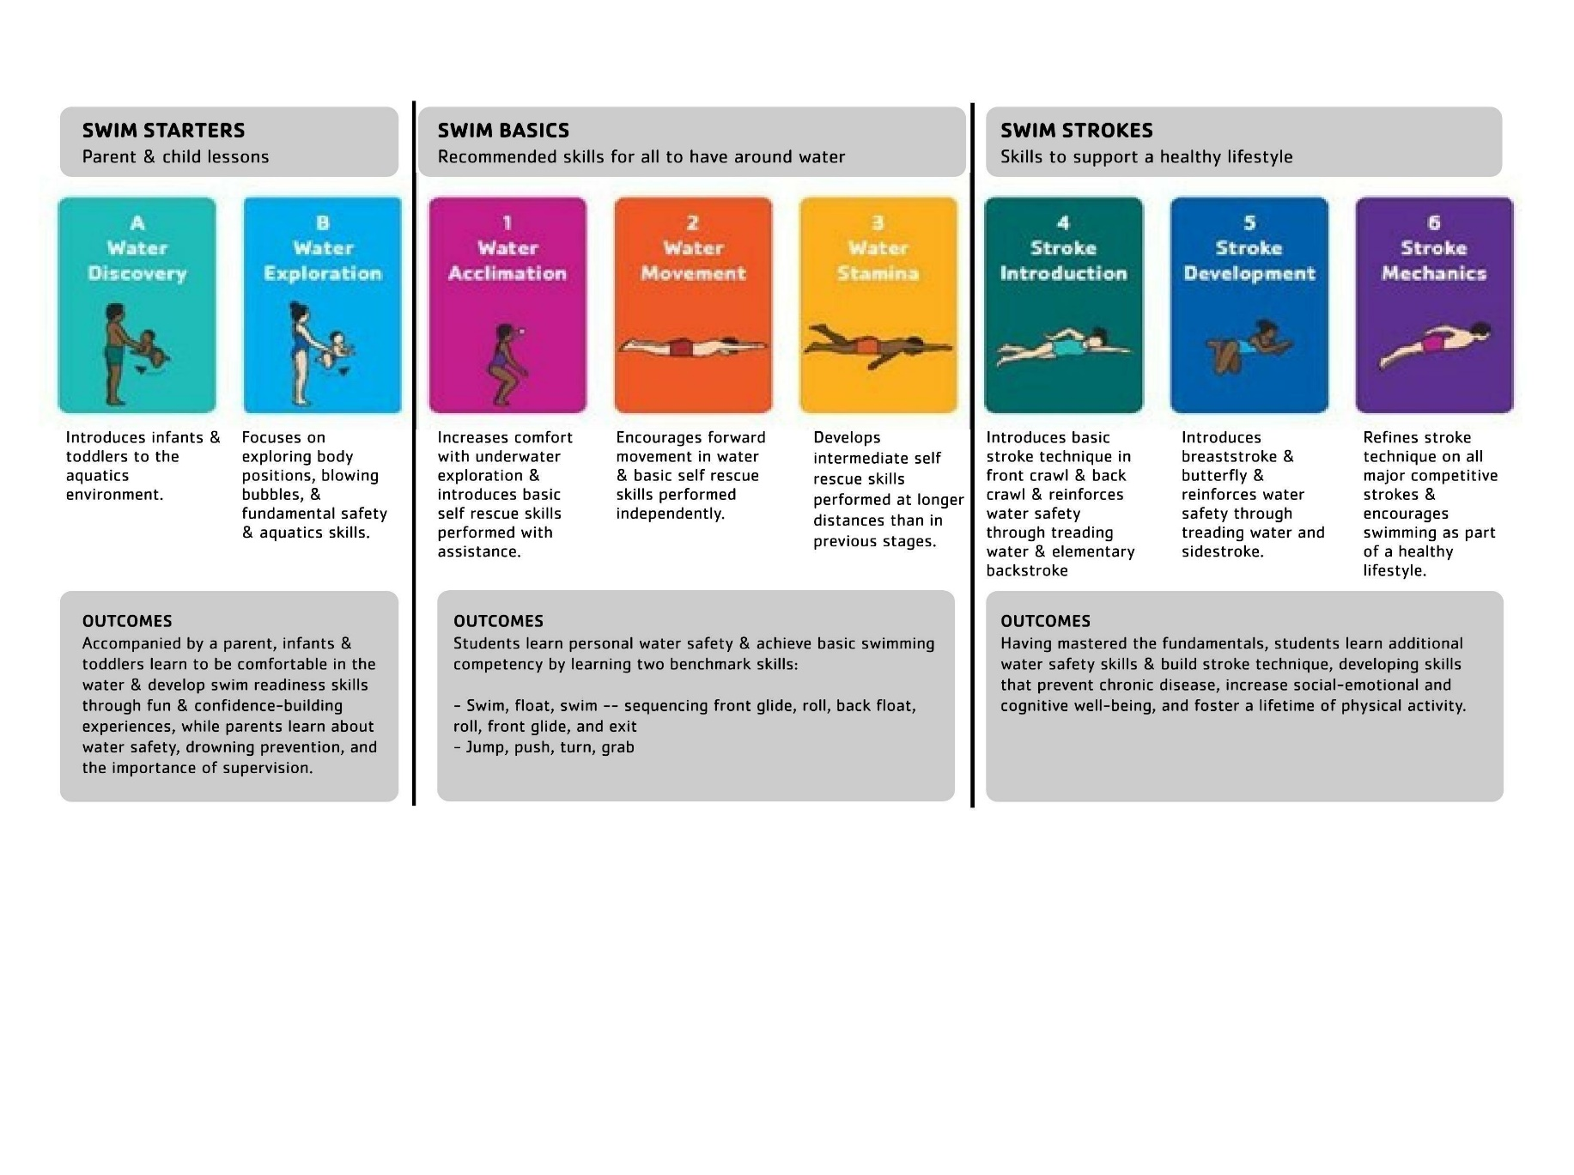
SWIM STAGES

