**How to change your signature block:**

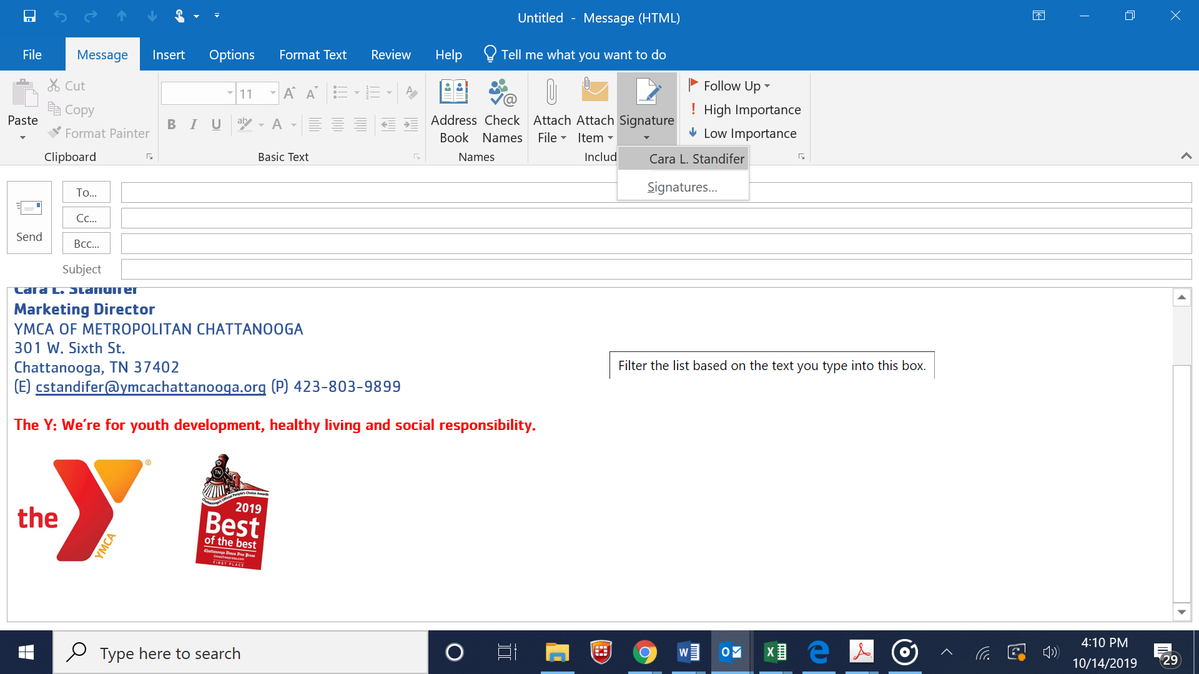

* Open a new email message and click at the top for “Signature.”
* Then click on “Signatures”

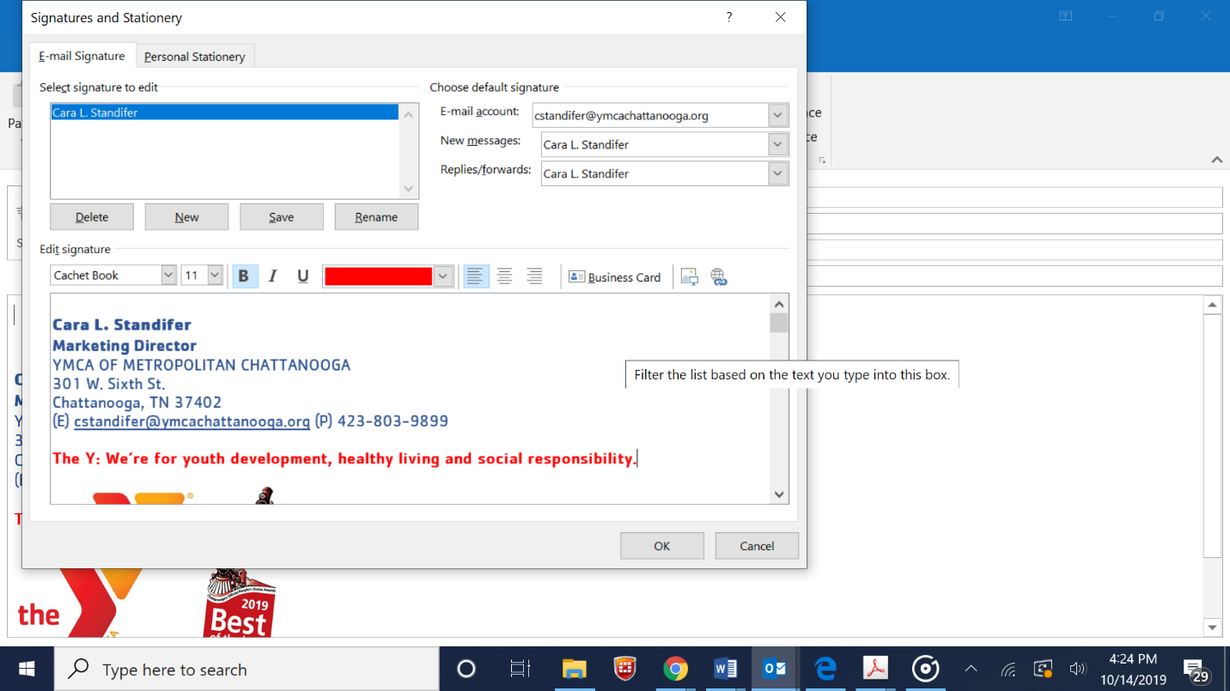

* Place your cursor at the end of your current signature block and press ENTER to space down.

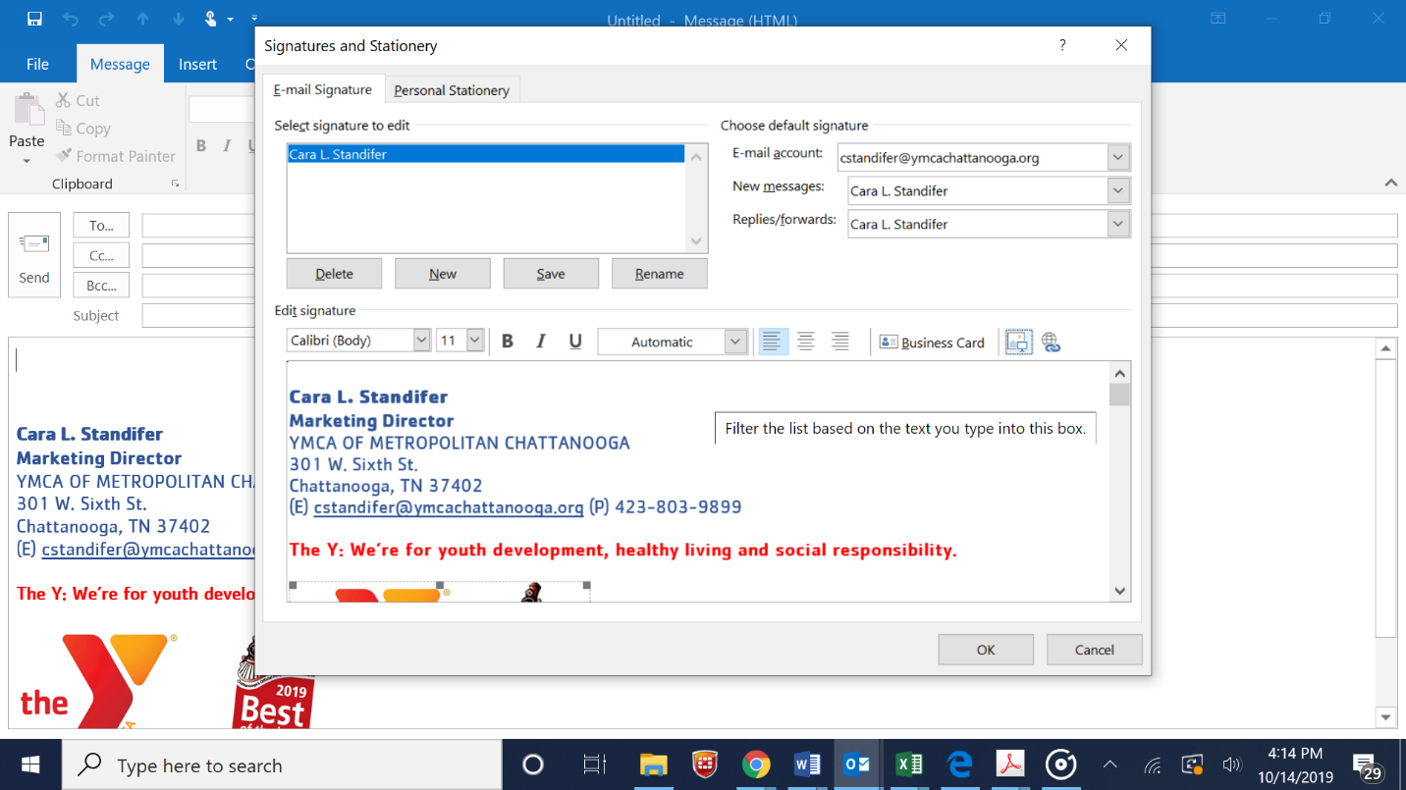

* Click on the image icon here to upload an image under your signature

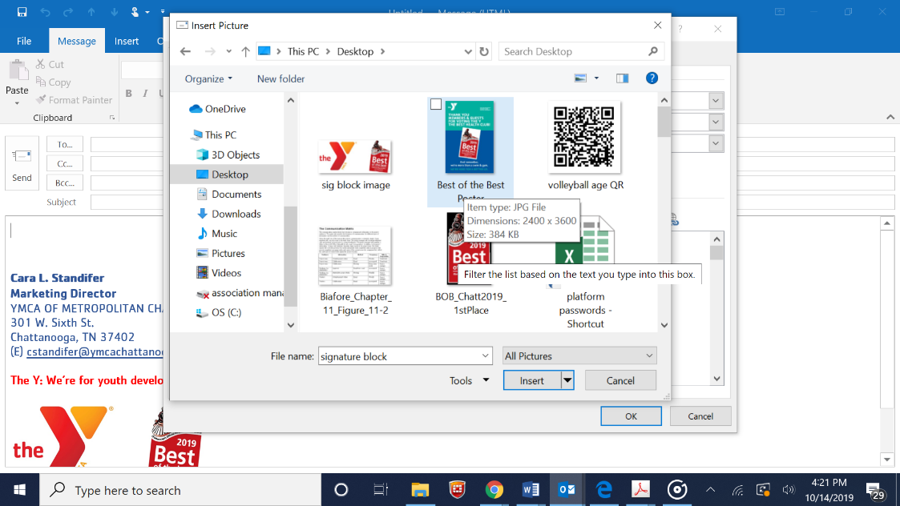

* Find the image you saved and click on it and then select “INSERT”
* Click “Ok”
* Open a new Outlook message and test that the signature block image was saved.
* Good to go!

